**Scientific Methods Vocabulary**

**Observations and Hypotheses**

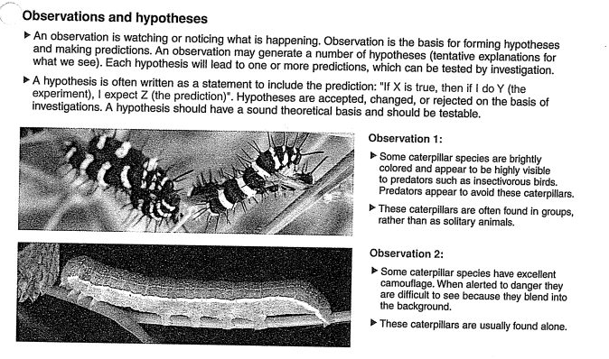

**Assumptions**

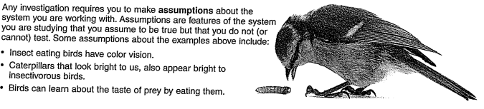

**Hypothesis vs. Prediction**

Hypothesis:

* States what is expected to happen and why
* Must be testable and falsifiable

Prediction:

* Uses an “if…then…” statement to predict the relationship between two variables.

**Examples:**

Hypothesis:

The pendulum will have a shorter period when the string is smooth in texture, because air resistance is minimized.

Prediction:

If the string arm of a pendulum is smooth in texture, then the period will be shorter compared to a rougher material.

**Designing an Experiment.**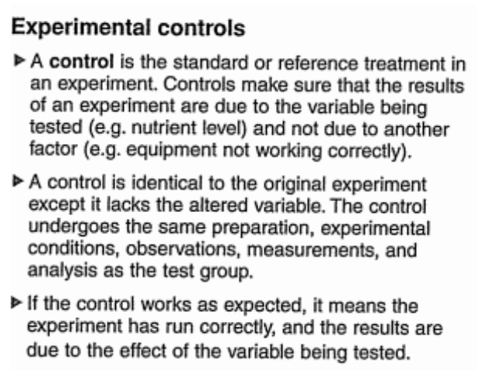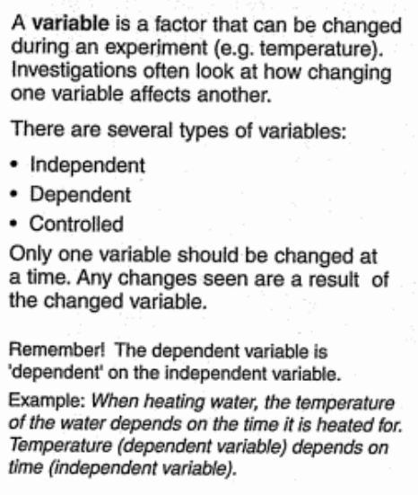

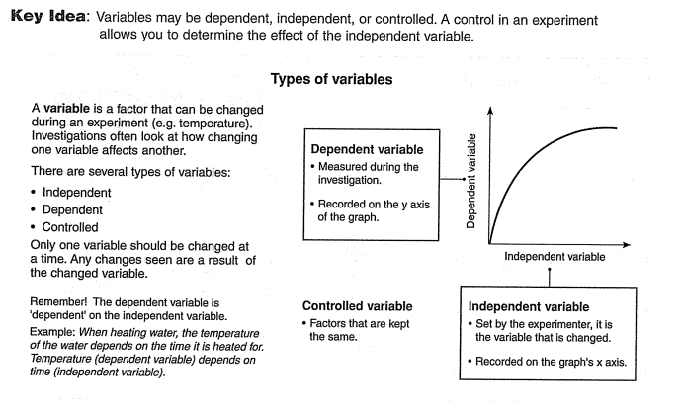

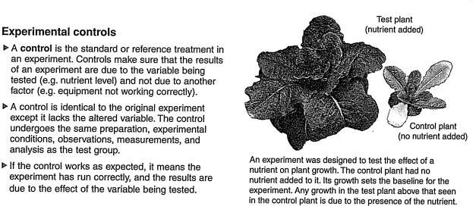

**Types of Data**

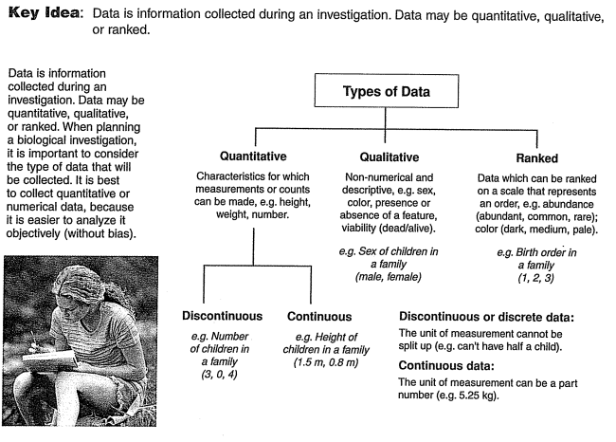

**Analyzing Data**

Positive Variation- as the x value increases linearly, so does the y value

Negative Variation- as the x value increases linearly, the y decreases or vice versa

No correlation- there is not linear or exponential relationship (a flat line or random scatter or zigzag)

Exponential variation- line curves

